Probability Lessons
BSU Math 6600

Jared Anderson
Comfrey High School
janderson@comfrey.mntm.org

James Bettin
Clearbrook Gonvick
jbettin@clearbrook-gonvick.k12.mn.us

Troy Faulkner
Byron High School
troy.faulkner@byron.k12.mn.us

Grades: 7 - 12
Executive summary: This probability unit will cover various topics and some topics can be used as standalone topics. The lessons are as follows: Probability Misconceptions (1 day), Finding the Sample Space (1 day), Law of Large Numbers (3 days), Finding Theoretical Probability of “or”, “and”, “then” (1 day), Monty Hall Problem (1 day), Roller Derby (1 day), Probability Mazes/Caves (2 days), Shooting Free Throw Problem {making 2 FT, making 2 FT given made one, making 2 Ft given made the first shot} (2 days), How to have n girls out of 5 children in a family? (1 day), Winning the Best 2 out of 3 {3 out of 5, 4 out of 7} (3 days), and Expected Value (1 day). All topics start with a launch (getting students hooked), followed by students exploring the topic then sharing with you and each other then the teacher summarizing the main ideas from the topic.
Standards:
7.4.3.1, 7.4.3.2, and 7.4.3.3 Calculate probabilities and reason about probabilities using proportions to solve real world and mathematical problems.
9.4.3.1 Select and apply counting procedures, such as the multiplication and addition principles and tree diagrams, to determine the size of a sample space (the number of possible outcomes) and to calculate probabilities.
9.4.3.2 Calculate experimental probabilities by performing simulations or experiments involving a probability model and using relative frequencies of outcomes.
9.4.3.3 Understand that the Law of Large Numbers expresses a relationship between the probabilities in a probability model and the experimental probabilities found by performing simulations or experiments involving the model.
9.4.3.5 Apply probability concepts such as intersections, unions and complements of events, and conditional probability and independence, to calculate probabilities and solve problems.
9.4.3.7 Understand and use simple probability formulas involving intersections, unions and complements of events.
9.4.3.8 Apply probability concepts to real-world situations to make informed decisions.

Table of Contents (hyperlinked for your convince)

Page 1 Title Page
Page 2 Executive Summary
Page 2 MN Standards
Page 3 Table of Contents
Page 4 Probability Misconceptions
Page 6 Finding the Sample Space
Page 9 Law of Large Numbers
Page 14 Theoretical Probability of “or”, “and”, “then”
Page 15 Monty Hall Problem
Page 16 Roller Derby
Page 18 Probability Mazes/Caves
Page 22 Free Throw Problem
Page 25 How to have n girls out of 5 children in a family.
Page 26 Winning the Best 2 out of 3?
Page 27 Winning the Best 3 out of 5?
Page 28 Winning the Best 4 out of 7?
Page 30 Expected Value
Page 32 Expected Value Practice Problems
Page 35 Probability Practice Problems
Page 37 Pre/Post-Test
Page 39 MCA Sample Questions

Probability Misconceptions (Ideas taken from CIMT, University of Exeter Probability Unit.)
Launch: This activity is intended to provide an opportunity to discuss common probability misconceptions. The statements given are all incorrect. They can be copied onto cardstock, cut out and distributed to small groups of students.
Explore: After students have been given enough time to think about and discuss common misconceptions, facilitate a whole group discussion on each statement.
Share: Students will share their finding with the class.
Summarize: Remind students that probability can be a bit counterintuitive! Even though we may tend to think that after flipping 10 heads in a row we are more likely to get a tail, but the next flip is independent of the previous flips, and is therefore still a 50% chance.
1. I flipped a fair coin three times and got 3 tails in a row. It is more likely that I flip a head if I flip again. | 2. There are 3 red blocks and 5 blue blocks in a bag. I choose a block at random. The probability that the block is red is 60%.
3. Anytown Rovers play a soccer game against Betown United. Anytown can win, lose, or draw, so the probability Anytown will win is 1/3. | 4. It is harder to roll a 6 than it is to roll a 3 on a number cube.
5. John buys 2 raffle tickets. If he chooses two tickets from different places in the book he is more likely to win than if he chooses two consecutive tickets. | 6. My Grandpa smoked 20 cigarettes a day for 60 years and lived to be 90, so smoking can’t be bad for you.
7. 13 is an unlucky number so you are less likely to win a raffle with a ticket number of 13 than with a different number. | 8. If 6 fair number cubes are rolled at the same time, I am less likely to get 1, 1, 1, 1, 1, 1, than 1, 2, 3, 4, 5, 6.

Finding the Sample Space
Launch: Jared and James were arguing about what are all the outcomes for flipping two coins, rolling on dice, and rolling two dice. I need you to settle the argument between James and Jared.

Explore: Make an organized list, a tree diagram (for two coins) and an area (array) model (for two coins and for two dice).

Share: Have students put their work on the board and compare their results.
- HH, HT, TH, TT
- 1, 2, 3, 4, 5, 6
- (1,1), (1,2), (1,3), (1,4), (1,5), (1,6), (2,1), (2,2), (2,3), (2,4), (2,5), (2,6), (3,1), (3,2), (3,3), (3,4), (3,5), (3,6), (4,1), (4,2), (4,3), (4,4), (4,5), (4,6), (5,1), (5,2), (5,3), (5,4), (5,5), (5,6), (6,1), (6,2), (6,3), (6,4), (6,5), (6,6)
- 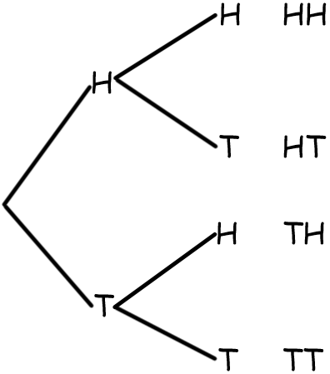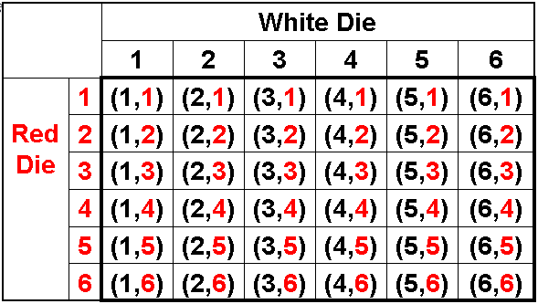
- 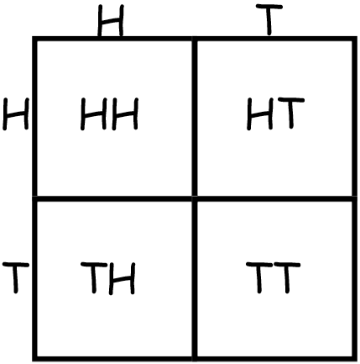
Summarize:
- Discuss the advantages and disadvantages of each method. One item (like one coin, one dice …) a list is very easy. If two items (two coins and two dice) then an array/area model are very useful. A tree diagram can be useful if the number of choices is not too many but is not hard to do when the choices are fewer like flip a coin 3 times, or flip a coin and roll a dice.
HARD Do-able
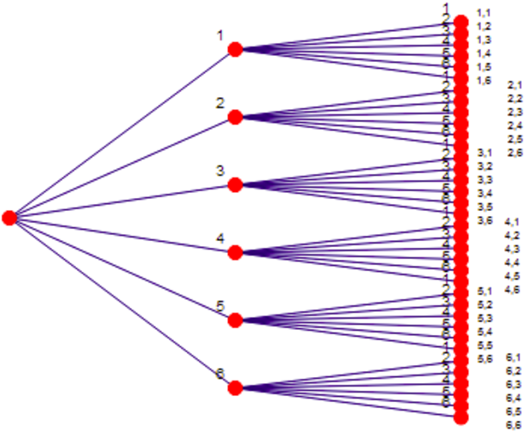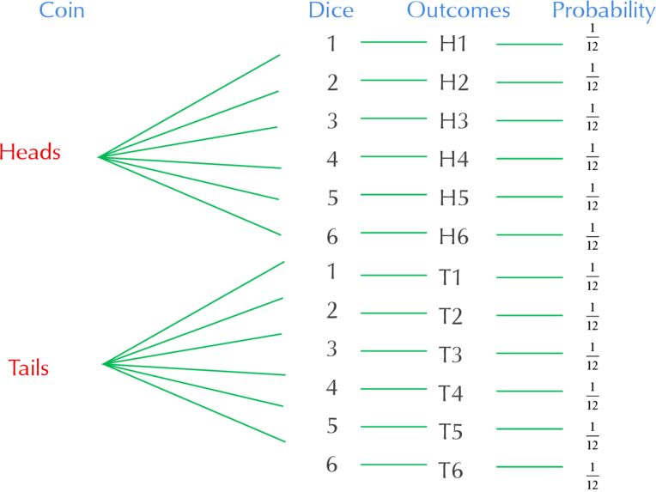

Law of Large Numbers (taken from BSU’s Math 6600)
Launch: If I flip a coin, what is the probability of getting a head? If I flip a coin 10 times, I will get how many heads?
Explore: We are going to collect some data. Everyone in the classroom will collect some data today on flipping coins. You will be recording your results from flipping a coin for each day of the month then in the table below you will be recording the total number of heads through that day and calculating the percent of heads through that given day. Then graph the percentages of each day on the graph following and connect each percentage to the prior percentage with a line segment.
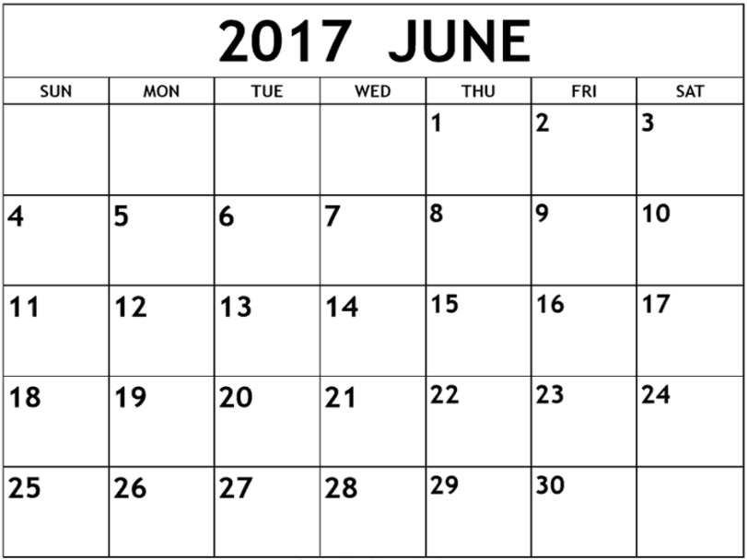

Total Number of Heads
Number of Days | 1 | 2 | 3 | 4 | 5 | 6 | 7 | 8 | 9 | 10
Percent of Heads

Total Number of Heads
Number of Days | 111 | 12 | 13 | 14 | 15 | 16 | 17 | 18 | 19 | 20
Percent of Heads

Total Number of Heads
Number of Days | 211 | 22 | 23 | 24 | 25 | 26 | 27 | 28 | 29 | 30
Percent of Heads

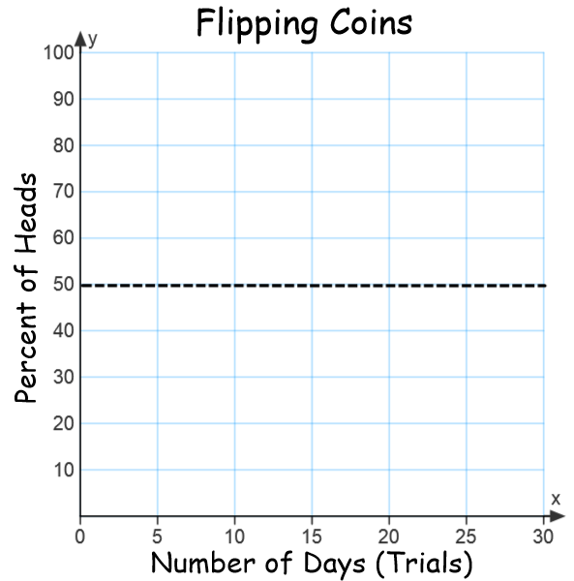
Share:
- Have each student give you their number of heads (record in a spreadsheet) then have each student tape the Flipping Coins graphs on the board/wall in one of two sections. Section 1 if their graph started out at 100% or section 2 if their graph started out at 0%.
Summarize:
- Ask the students to make some observations about the individual student graphs.
- Make a graph in your spreadsheet of all the results to help them see that the more trails the closer the class results get closer to 50%. Ask them how many trials would be needed for the percentage to be exactly 50%? 10000, 100000, a million???
- The big idea is that the more trials that are done the closer and closer the average should be to the theoretical probability.

Law of Large Numbers (Part 2)
Launch: James and Jared are developing some games for some younger students but they need to estimate the probabilities of these games. These games a little more complicated than the game you did yesterday. The games are flipping two coins and getting two tails, rolling one die and getting a 2 or a 5, rolling one dice and getting an even number and a prime, rolling two dice and getting at least one even, and the last game is rolling two dice and getting a 2 then a 5.
Explore: Have the students keep track of their results and have a running probability after each trial and plot their results. Print off the next graph and give to students. Each student should have one graph for each game.
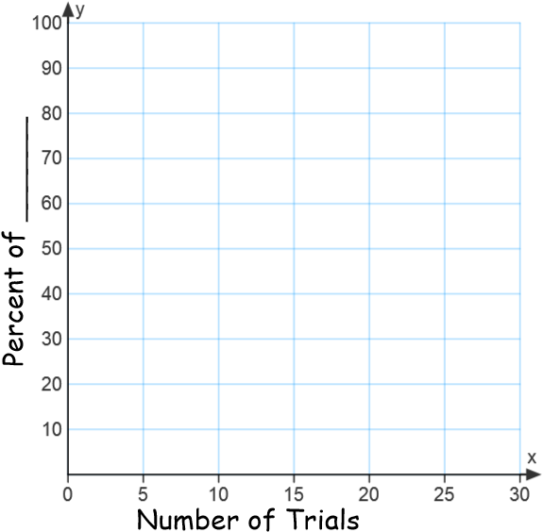
Share:
- Have each student give you their number of successes (record in a spreadsheet) for each game then have each student tape their graphs on the board/wall in one of two sections. Section 1 if their graph started out at 100% or section 2 if their graph started out at 0% for each game.
Summarize:
- Ask the students to make some observations about the individual student graphs.
- Make a graph in your spreadsheet of all the results for each game to help them see that the more trails the closer the class results get closer to the theoretical probability or what we would expect. Ask them how many trials would be needed for the percentage to be exactly 50%? 10000, 100000, a million???
- The big idea is that the more trials that are done the closer and closer the average should be to the theoretical probability.

Theoretical Probability of “or”, “and”, “then”
Launch: James and Jared are developing those games from yesterday for some younger students but they need to know the actual probabilities of these games. The games are flipping two coins and getting two tails, rolling one die and getting a 2 or a 5, rolling one dice and getting an even number and a prime, rolling two dice and getting at least one even, and the last game is rolling two dice and getting a 2 then a 5.
Explore: Have students develop the sample spaces for each game and they must represent each sample space in at least two ways (numeric, organized list, tree diagram, or area model). Have them find the probabilities of each game. Review what probability is. 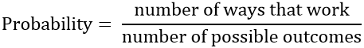
Share: Have the students put their work and answers of the board.
Summarize: Summarize what the different words of “or”, “and”, “at least”, and “then” affect a situation. If the students did not include all the different types (numeric, organized list, tree diagram, or area model) then put up on the board any missing models for finding the probabilities for each game and help students understand why the probability is what it is from each model for each game.

Monty Hall Problem
Launch: The Monty Hall problem is a counter-intuitive statistics puzzle:
- There are 3 doors, behind which are two goats and a car.
- You pick a door (call it door A). You’re hoping for the car of course.
- Monty Hall, the game show host, examines the other doors (B & C) and always opens one of them with a goat (Both doors might have goats; he’ll randomly pick one to open)
Here’s the game: Do you stick with door “A” (original guess) or switch to the other unopened door? Does it matter?
Explore: Use the material on “https://betterexplained.com/articles/understanding-the-monty-hall-problem/ ” so that students can play the game and keep track of their results as a class.
Switch |  |  | Stay
Win Car | Lose Goat |  | Win Car | Lose Goat
Follow the below steps to help students understand.
- Understanding Why Switching Works
- Understanding The Game Filter
- Overcoming Our Misconceptions
- The more you know…
- Visualizing the probability cloud
- Generalizing the game
- Summary
Roller Derby (taken from BSU’s Math 6600)
Launch: Students will be playing Roller Derby. Each pair of students will compete using a game board with columns numbered 1 – 12, a pair of dice, and 12 markers. Each student places markers on the columns of choice. To see who starts, each player rolls a dice, the player with the highest roll goes first. Players take turns rolling and removing markers from the column that the sum matches. The first player to remove all markers wins.

Explore: Allow time for students to play a round of roller derby. Observe student strategies. Ask students if they need to revise their strategy after playing one game. Most students will move more markers towards the center, realize it’s impossible to get a sum of 1, etc.

Summarize: After students have played a few rounds of roller derby, discuss winning strategies. Assist students with representing the sample space several different ways, such as an addition table or line plot. After completing sample space, ask the following questions. When we roll two number cubes, how many different number pairs are possible? (36) Are these pairs equally likely? (Yes) How many different sums are possible? (11) Are these sums equally likely? (No) When you roll two number cubes, what is the probability that the sum will be 12? (1/36) What is the probability that the sum will be 1? (0) What is the probability that the sum will be 0? (0)
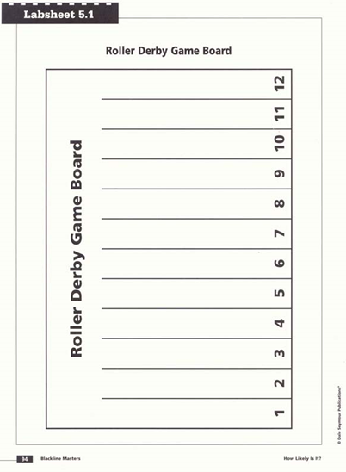
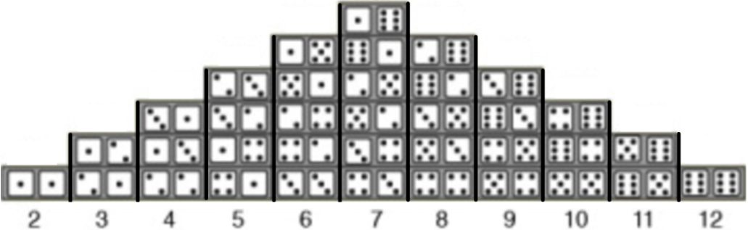

Probability Mazes/Caves (taken from BSU’s Math 6600)
Practice with some simple area models:
You are given two baskets, two white marbles, and two red marbles. Which arrangement of the two white and two red marbles in the baskets gives the best chance of drawing a white marble?
Make a copy of the basket activity for each student. Go over each probability model so that students are comfortable with simple probability. This is a warm-up for the Pirate Island activity.

Launch: On Pirate Island, students will be hiding their treasure in cave A or in cave B. Try to make your treasure as difficult as possible to find. After students have decided on which cave, have students calculate the probability using an area model and tree diagram.
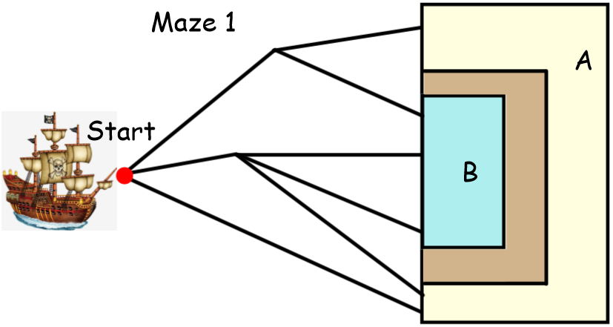

P(A)= 14/36 P(B)= 22/36
Explore: Have students work together in pairs to find the probability of next two mazes. Students need to use an area model and tree diagram to support their conclusions.

Share: Have several groups put up area models and tree diagrams on board for discussion. Check to be sure students agree on probability for the first maze of P(A)= 14/36, and P(B)= 22/36, and the second maze of P(A)= 36/72 and P(B)= 36/72. Have students share which model they like better and why.

Summarize: Remind students that probability is the favorable number of outcomes over the total number of outcomes. Remind students that standardized tests will probably want all answers in simplest form. Students can also find the odds of arriving on section A and section B after the probability has been determined.

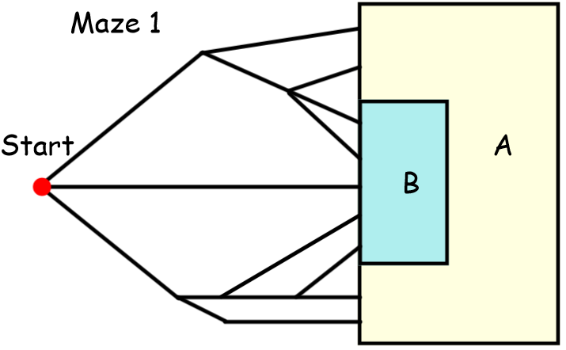
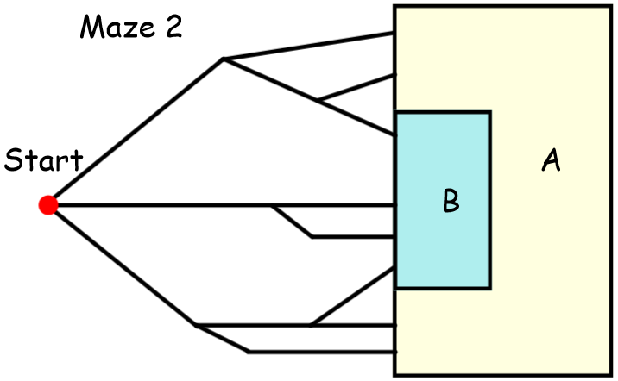

Free Throw Problem (taken from BSU’s Math 6600)
Launch: Glen is watching the final seconds of a basketball game then at 0.1 seconds left a foul is called. Craig will be shooting two free throws, with Craig’s team down my one. However Glen’s wife comes along before Craig shoots the free throws and changes the TV channel to watch a craft show. After the craft show Glen is watching the highlights of the games and sees that Craig made one basket then Glen’s wife turns the channel again. Glen does not know if the basket he saw Craig make is the first basket or the second basket.
Explore: Find the following probabilities given Craig is a 70% free throw shooter: Craig makes both baskets, Craig makes both baskets given he made the first, Craig makes both baskets given he makes one, and Craig makes only one of his two shots. Answers should include area probability model and the numeric model.
Find the following probabilities given Craig is a 90% free throw shooter: Craig makes both baskets, Craig makes both baskets given he made the first, Craig makes both baskets given he makes one, and Craig makes only one of his two shots. Answers should include area probability model and the numeric model.
Find the following probabilities given Craig makes 5 out of 7 free throw shoots: Craig makes both baskets, Craig makes both baskets given he made the first, Craig makes both baskets given he makes one, and Craig makes only one of his two shots. Answers should include area probability model and the numeric model.

Share: Have students put their models, work and answers on the board.

Day 2 extension: Given a family has two children find P( of two boys), P(two boys given first is a boy), and P(two boys given one is a boy).
Find the following probabilities given Craig makes “A” out of 7 free throw shoots: Craig makes both baskets, Craig makes both baskets given he made the first, Craig makes both baskets given he makes one, and Craig makes only one of his two shots. Answers should include area probability model and the algebraic model.

Summarize: Find the following probabilities given Craig makes “A” out of “B” free throw shoots: Craig makes both baskets, Craig makes both baskets given he made the first, Craig makes both baskets given he makes one, and Craig makes only one of his two shots. Answers should include area probability model and the algebraic model.
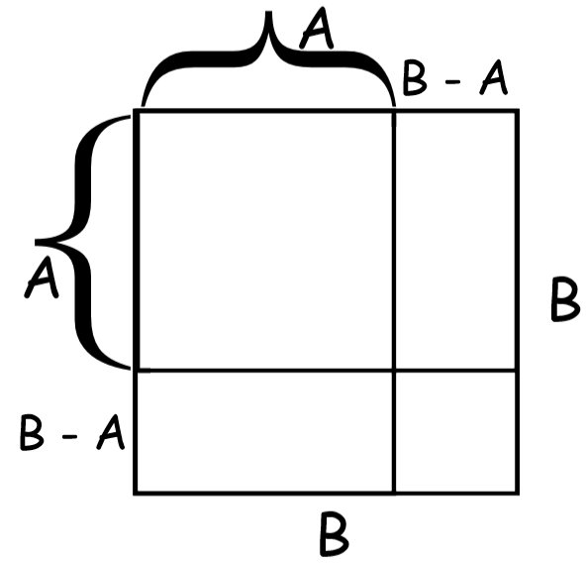
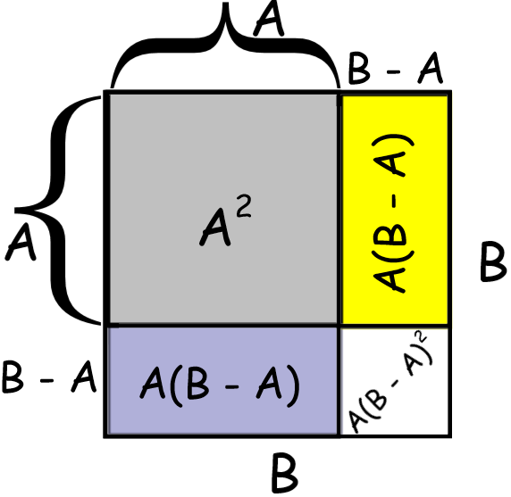
P(Craig makes both) = Gray out of All or 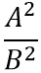
P(Craig makes both baskets given he made the first) = Gray out of Gray and Yellow = 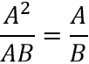
P(Craig makes both baskets given he makes one) = Gray out of Gray, Yellow and Aster Purple = 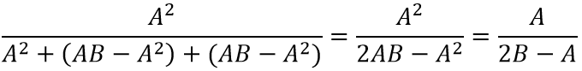
P(Craig makes only one of his two shots) = Yellow and Aster Purple out of the total of B² = 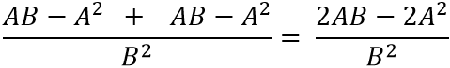

How to have n girls out of 5 children in a family.
(taken from BSU’s Math 6600)
Launch: You have been watching families at the Mall of America and you have noticed some families with five kids. You have noticed that most of the five children families that you have seen have two girls which makes you think about how many ways a family of five can have two girls.
Explore: How many ways can a family have two girls in a family of five children and what is the probability of that occurring? (Could be done with an organized list, tree diagram …)
Teacher Resource: Here is a link to a video I record on this problem. https://www.youtube.com/watch?v=LaRK8bEpJlA&t=233s
Share: Have students put their results and work on the board. Then have the students answer the following questions. How many ways can a family have three girls in a family of five and what is the probability of that occurring? How many ways can a family have four girls in a family of five and what is the probability of that occurring? How many ways can a family have five girls in a family of five and what is the probability of that occurring? How many ways can a family have zero girls in a family of five and what is the probability of that occurring? How many ways can a family have one girl in a family of five and what is the probability of that occurring?
Summaries: Has anyone ever seen the ways you can have r girls in a family of 5 (1, 5, 10, 10, 5, 1) before? {Pascal’s Triangle and/or combinations}
In general to have r girls in a family of five: ₅C_{r} (0.5)^{r}(0.5)^{5-r}
What is the probability of having r girls out of m in the family of n? _{n}C_{r} (0.5)^{r}(0.5)^{n-r}

Winning the Best 2 out of 3 (3 out of 5, 4 out of 7)?
Launch: The Twins and Yankees played multiple times throughout the regular season. The Yankees won 60% of their games against the Twins. Yet the Twins and the Yankees have wound up in the World Series. What are the chances (probability) of the Twins winning and what is the chance (probability) of the Yankees winning?
Best 2 out of 3
Given the probability of the Yankees winning is 60% while the probability of the Twins winning is 40%.
Give students time to think and explore this problem. Students can be encouraged to make an organized list of ways to win and then verify that they have all possibilities by making a tree diagram.

In the work below W means Yankees won (or Twins lost) and L means the Yankees lost (or the Twins won).
P(the Yankees winning best 2 out of 3)
WW = 0.6 * 0.6 = 0.36
WLW = 0.6*0.4*0.6 = 0.144
LWW = 0.4*0.6*0.6 = 0.144
Total P(the Yankees winning best 2 out of 3) = 0.36 + 0.144 + 0.144 = 0.648

P(the Twins winning best 2 out of 3)
LL = 0.4*0.4 = 0.16
LWL = 0.4*0.6*0.4 = 0.096
WLL = 0.6*0.4*0.4 = 0.096
Total P(the Twins winning best 2 out of 3) = 0.16 + 0.096 + 0.096 = 0.352

Best 3 out of 5
Given the probability of the Yankees winning is 60% while the probability of the Twins winning is 40%.
Give students time to think and explore this problem. Students can be encouraged to make an organized list of ways to win and then verify that they have all possibilities by making a tree diagram.

In the work below W means Yankees won (or Twins lost) and L means the Yankees lost (or the Twins won).
Short cut way to know if you have listed all the possible ways to win three out of five games is five combination three or ₅C₃ which is ten.
P(the Yankees winning best 3 out of 5)
WWW = 0.6 * 0.6 * 0.6 = or (0.6)³ = 0.216
WWLW, WLWW, LWWW = 3(0.6)³(0.4) = 0.2592
WWLLW, WLLWW, WLWLW, LWWLW, LWLWW, LLWWW = 6(0.6)³(0.4)² = 0.20736
Total P(the Yankees winning best 3 out of 5) = 0.216 + 0.2592 + 0.20736 = 0.68256

P(the Twins winning best 3 out of 5)
LLL = (0.4)³ = 0.064
LLWL, LWLL, WLLL = 3(0.4)³(0.6) = 0.1152
LLWL, LWWLL, LWLWL, WLLWL, WLWLL, WWLLL = 6(0.4)³(0.6)² = 0.13824
Total P(the Twins winning best 3 out of 5) = 0.064 + 0.1152 + 0.13824 = 0.31744

What is a second way we could have figured out the probability of the Twins winning the best three out of five? {1 - P(Yankees winning)} Why is it nice to show all the work of the probability of the Twins winning? {to see if the probability of Yankees plus probability of Twins winning is one}

Best 4 out of 7
Summarize: Find the probability of the Yankees winning best four out of seven games and the probability of the Twins winning the best four out of seven games.

Answer to Summary Problem
In the work below W means Yankees won (or Twins lost) and L means the Yankees lost (or the Twins won).
Short cut way to know if you have listed all the possible ways to win four out of seven games is seven combination four or ₇C₄ which is 35.
P(the Yankees winning best 4 out of 7)
- 4 games: WWWW = 1(0.6)⁴ = 0.1296
- 5 games: WWWLW, WWLWW, WLWWW, LWWWW = 4(0.6)⁴(0.4) = 0.20736
- 6 games: It is hard to list all of the possible ways to win 4 out of the 6 games, but consider the pattern WWWLLW, WWLWLW, WWLLWW … Notice the last game must be a win so all we have to do is to look at the first 5 games and figure out how many ways can we win 3 out of 5 games or ₅C₃ which is 10. = 10(0.6)⁴(0.4)² = 0.20736
- 7 games: It is also hard to list all of the possible ways to win 4 out of the 7 games, but consider the pattern WWWLLLW, WWLWLLW, WWLLWLW … Notice the last game must be a win so all we have to do is to look at the first 6 games and figure out how many ways we can win 3 out first 6 games or ₆C₃ which is 20. = 20(0.6)⁴(0.4)³ = 0.165888
- Note: the number of games should be 35 (₇C₄) and 1 + 4 + 10 + 20 = 35 so we have included all possible ways to win the best 4 out of 7 games.
Total P(the Yankees winning best 4 out of 7) =
0.1296 + 0.20736 + 0.20736 + 0.165888 = 0.710208

P(the Twins winning best 4 out of 7)
Note: to figure out how many ways the Twins can win just take all the options for the Yankees winning and switch all the W’s with L’s and all the L’s with W’s.
- 4 games: LLLL = 1(0.4)⁴ = 0.0256
- 5 games: LLLWL, LLWLL, LWLLL, WLLLL = 4(0.4)⁴(0.6) = 0.06144
- 6 games: It is hard to list all of the possible ways to win 4 out of the 6 games, but consider the pattern LLLWWL, LLWLWL, LLWWLL … Notice the last game must be a lose so all we have to do is to look at the first 5 games and figure out how many ways can we lose 3 out of 5 games or ₅C₃ which is 10. = 10(0.4)⁴(0.6)² = 0.09216
- 7 games: It is also hard to list all of the possible ways to win 4 out of the 7 games, but consider the pattern LLLWWWL, LLWLWWL, LLWWLWL … Notice the last game must be a lose so all we have to do is to look at the first 6 games and figure out how many ways we can lose 3 out first 6 games or ₆C₃ which is 20. = 20(0.4)⁴(0.6)³ = 0.110592
Total P(the Twin winning best 4 out of 7) =
0.0256 + 0.061444 + 0.09216 + 0.110592 = 0.289792
Note: the P(Yankees win best 4 out of 7) + P(Twins win best 4 out of 7) = 1 : )

Expected Value (taken from BSU’s Math 6600)
Launch: Let's play a couple of games however it costs $1 to play each game but if you play the games you could win some money. Game 1: If you draw a Club from a standard deck of cards then you win $2. Game 2: If you draw a King from a standard deck of cards then you win $9. Game 3: If you draw the Ace of Hearts from a standard deck of cards then you win $49. Game 4: If you roll two dice and get doubles then you win $4. Game 5: If you roll 2 dice and the product of the two numbers showing on the dice is odd then you win $2. Game 6: An Ace corresponds to January, a Two corresponds to February and so on with a Queen corresponding to December, if you draw a month with one “e” then you win $1 but if you draw a month with more than one “e” then you win $2. Game7: If you flip three coins and get three heads then you win $2 but if you get three tails then you win $3. Which two games would you like to play most because you think you could win the most?

Explore: Divide your class into seven groups and each group sets up one of the games. One person from each group will stay with their game and record data (for each time the game is played record cost to play, the result and how much was won) while the other members of their group go and play the other games. After eight minutes one of the group members goes and records data so that the original data recording person can play games too. After a set time have students calculate how much money was won for their game and subtract all the money it cost to play the game then divide by how many times it was played. This is the average amount of money won or lost.

Share: Have the students share their results with you as you record the results of each game. How many students choose one of the top two games to play? In front of the whole class talk about the average amount of money won or lost in each game was the experimental expected value.

Summarize: Then calculate the actual expected value for the first three games together as a class then let the students calculate the expected value for each of the remaining games and put their results on the board. Expected value is the cost to play (a negative amount) + the probability multiplied by the amount won for each situation of the game or cost plus winnings.
Game 1: 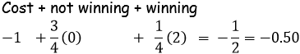

Game 2: 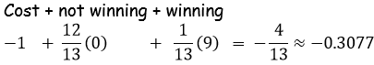

Game 3: 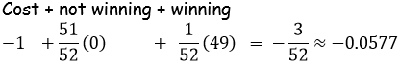

Game 4: 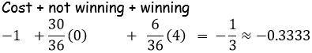

Game 5: 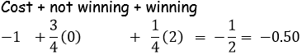

Game 6: 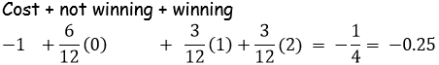

Game 7: 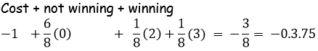
Expected Value Practice Problems
1. You draw one card from a standard deck of playing cards. If you pick a heart, you will win $10. If you pick a face card, which is not a heart, you win $8. If you pick any other card, you lose $6. Do you want to play? Explain.
Expected value = (13/52)(10) + (9/52)(8) + (30/52)(-6) = $.42
Expected value is you win $.42, so you want to play
2. The world famous gambler from Philadelphia, Señor Rick, proposes the following game of chance. You roll a fair die. If you roll a 1, then Señor Rick pays you $25. If you roll a 2, Señor Rick pays you $5. If you roll a 3, you win nothing. If you roll a 4 or a 5, you must pay Señor Rick $10, and if you roll a 6, you must pay Señor Rick $15. Is Señor Rick crazy for proposing such a game? Explain.
Expected value = (1/6)(25) + (1/6)(5) + (1/6)(0) + (2/6)(-10) + (1/6)(-15) = $-.83
Señor Rick is not crazy since the expected value is you loose $ -.83.
3. You pay $10 to play the following game of chance. There is a bag containing 12 balls, five are red, three are green and the rest are yellow. You are to draw one ball from the bag. You will win $14 if you draw a red ball and you will win $12 is you draw a yellow ball. How much do you expect to win or loose if you play this game 100 times?
Expected value of 1 game = (5/12)(4) + (4/12)(2) + (3/12)(-10) = $-.1667
Expected value of 100 games = 100(-.1667) = $-16.67, you loose $16.67
4. A detective figures that he has a one in nine chance of recovering stolen property. His out-of-pocket expenses for the investigation are $9,000. If he is paid his fee only if he recovers the stolen property, what should he charge clients in order to breakeven?
Want an expected value of 0, let X = what he should charge
Solve: (1/9)(X - 9000) + (8/9)(-9000) = 0
X = 81000, so the detective must charge $81,000.
5. At Tucson Raceway Park, your horse, Soon-to-be-Glue, has a probability of 1/20 of coming in first place, a probability of 1/10 of coming in second place, and a probability of ¼ of coming in third place. First place pays $4,500 to the winner, second place $3,500 and third place $1,500. Is it worthwhile to enter the race if it costs $1,000?
Expected value = (1/20)(3500) + (1/10)(2500) + (1/4)(500) + (3/5)(-1000)= $-50
Not worthwhile to enter the race, he is expected to loose $50.
6. Your company plans to invest in a particular project. There is a 35% chance that you will lose $30,000, a 40% chance that you will break even, and a 25% chance that you will make $55,000. Based solely on this information, what should you do?
Expected value = .35(-30000) + .40(0) + .25(55000) = $3250
You expect to make $3,250, so proceed with the project.
7. A manufacturer is considering the manufacture of a new and better mousetrap. She estimates the probability that the new mousetrap is successful is 0.75. If it is successful, it would generate profits of $120,000. The development costs for the mousetrap are $98,000. Should the manufacturer proceed with plans for the new mousetrap? Why or why not?
Expected value = .75(120000) +.25(-98000) = $65,500
Expected profit of 65,500, proceed with the project.
8. A grab bag contains 12 packages worth 80 cents apiece, 15 packages worth 40 cents each and 25 packages worth 30 cents apiece. Is it worthwhile to pay 50 cents for the privilege of picking one of the packages at random?
Expected value of your prize = (12/52)(.80) + (15/52)(.40) + (25/52)(.30) = $.44
Expected value of your prize is $0.44, if you paid $0.50 then you lost money
9. You pay $3.00 to play. The dealer deals you one card. If it is a spade, you get $10. If it is anything else, you lose your money. Is this game fair?
Expected value for you = (13/52)(7) + (39/52)(-3) = $-.50
You expect to loose $.50 so not a fair game.
10. A casino game costs $3.50 to play. You draw 1 card from a deck. If it is a heart, you win $10; If it is the Queen of hearts, you win $50. Is this a fair game?
Expected value for you = (12/52)(6.5) + (1/52)(46.5) + (39/52)(-3.5) = $-.23
You expect to loose $.23 so not a fair game.
11. A player rolls a die and receives the number of dollars equal to the number on the die EXCEPT when the die shows a 6. If a 6 is rolled, the player loses $6. If the game is to be fair, what should be the cost to play?
Expected value = 1(1/6) + 2(1/6) + 3(1/6) + 4(1/6) + 5 (1/6) – 6(1/6) = $1.5
The expected value is $1.5 when games costs nothing so charge $1.50 to make the game fair (expected value =0).
-.5(1/6) + .5(1/6) + 1.5(1/6) + 2.5(1/6) + 3.5(1/6) – 7.5(1/6) = 0
12. Consider the above game with a modification. We would like to make a fair, FREE game. We will do this by charging a customer money if they roll a 1. If all the rest is the same, what should we charge if they roll a 1?
Fair game, so expected value = 0, X = outcome for a 1
0 = X(1/6) + 2(1/6) + 3(1/6) + 4(1/6) + 5 (1/6) - 6(1/6)
Solving for X we get = $-8;
We should charge $8 if they roll a 1.

Practice Problems
1. A three digit number is created by selecting three random digits from the following set: Numbers beginning with 0 are not permitted. What is the probability that one randomly selected number generated from the above list is not a multiple of 5?

2. Three men and three women are waiting to interview for a job. If the candidates are called in for their interviews in a random order, what is the probability that all three women will be interviewed first?

3. A student does not want to be late for his final exam in Statistics, so he sets the alarm on three battery-operated alarm clocks. If each individual alarm clock has a 10% chance of failing, what is the probability of all three alarm clocks failing?

4. What is the probability of drawing three random cards from a standard 52-card deck in the following order: a Jack, a Spade, a red non-face card (2, 3, 4, 5, 6, 7, 8, 9, or 10)?

5. “Five-card Draw” is a game using a standard 52-card deck where the players each draw a hand of five cards. A royal flush, consisting of the Ace, King, Queen, Jack, and ten from the same suit, is the best hand a player can have. What is the probability that a player will randomly draw a royal flush?

6. If three people are selected at random from the blood type chart below, what is the probability that at least one of them will be type O?
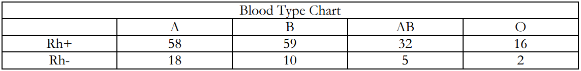

7. What is the probability that a randomly selected person from the chart above will have blood type B given that his/her blood is Rh+?

8. Joanna, a Statistics student, sits down to take her final exam and realizes that she doesn’t know the answers to any of the questions because she didn’t study at all. If there are 10 multiple choice questions with the options of A through D for each, and on the grading scale a 70% is required for a passing C, what is the probability that Joanna will get a 70% on her test if she randomly bubbles in answers? Assume that all questions are of equal point value and there is an equal likelihood that any letter will be correct.

Answers:
1. 2/3
2. 1/20
3. 0.001
4. 0.007
5. 0.00000154
6. 0.2476
7. 0.358
8. 0.0000061

Probability Pre/Post-Test
- Use the maze to find the probability of landing on section A and section B. Use a geometric model and tree diagram to show how you arrived at your answer.
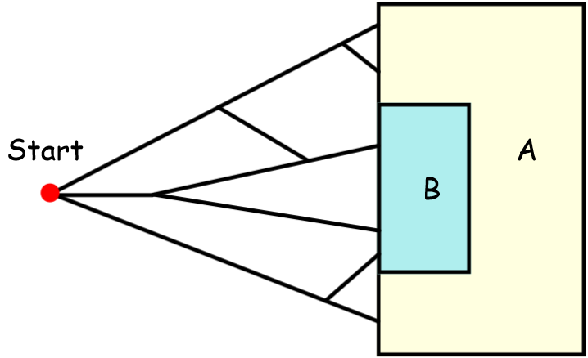

- Find the probability of landing in the purple shaded region.
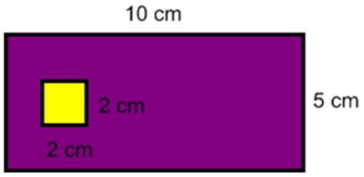

- Four friends-Bob, Bill, Ruth, and Raquel-are among the last to board a jet for a long flight home. Before they board, the flight attendant announces that because of seat limitations, only two of them may sit together. List the sample space for the seating arrangement.

- A fair coin was flipped 3 times and landed on heads all three times. Is it more likely that the next flip will be a tail? Explain your answer.

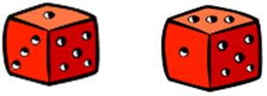
- You are going to play a game of roller derby. How will you arrange your markers? Use a sample space to justify your answer.

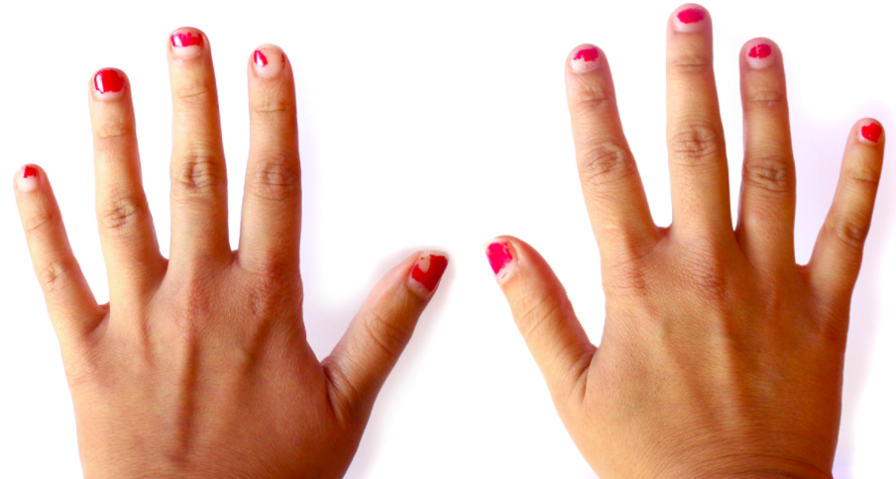
- Suppose that 100 individuals are randomly sampled from a very large population and part of a study of gender differences in handedness. For males, 43 were right-handed and 9 were left-handed. For females, 44 were right-handed and 4 were left-handed. Organize the data into a matrix and answer the following questions.
A) How many people were left-handed?
B) What is the probability of selecting a right-handed male?
C) If only females are taken into account, what is the probability of selecting a left-handed female?

7. This last game costs $1 to play. You are given a coin to flip. Any time you flip tails, the game ends. If you flip heads, you may flip again for a max of 5 flips. You will be paid $1 for each head. If all 5 flips result in heads, you win the $5 for 5 heads plus a $2 bonus. Is this a fair game?

MCA Sample Questions
- The probability of 2 people in any given group of 13 people having the same birthday is about 15%. Based on this information, what is the probability of 2 people in any given group of 13 not having the same birthday?
  - 2%
  - 13%
  - 50%
  - 85%

- The odds of picking a green marble from a bag that contains only blue, white, and green marbles are 4 to 9. What is the probability of picking a green marble from the bag?

- Matthew had exactly 20 pennies in his pocket. Five were Canadian pennies and the rest were U.S. pennies. If he took 1 penny out of his pocket at random, what are the odds that the penny would be Canadian?
  - 1 to 3
  - 1 to 4
  - 1 to 5
  - 1 to 20

- A bag contains 4 yellow tiles and 2 green tiles. A tile will be taken from the bag at random and set aside. A second tile will then be taken from the bag at random. What is the probability that both tiles will be green?
  - 31
  - 91
  - 151
  - 181

- A contingency table for a classroom is shown.
Class Roster

 | Junior | Senior | Total
Female | 8 | 9 | 17
Male | 6 | 7 | 12
Total | 14 | 16 | 30
Based on the table which probabilities are greater than 50%?

- Isabella flipped a fair coin 100 times. Which statement about Isabella’s outcomes is most likely true?
  - The coin landed heads up 50 times and tail up 50 times.
  - The number of times the coin landed heads up was less than 50.
  - If Isabella continues to flip the coin, the experimental probability of the coin landed heads up will increase.
  - If Isabella continues to flip the coin, the experimental probability of the coin landing heads up will approach ½.

- Eli receives a shipment of 40 new books for his bookstore: 5 biographies, 12 mysteries, 10 romances, 11 technical books, and 2 cookbooks. Eli randomly picks 2 books from the shipment. What is the probability that he pick a biography and then picks a technical book?

8. A warning system installation consists of two independent alarms having probabilities of 0.95 and 0.90, respectively, of operating in an emergency. Find the probability that at least one alarm operates in an emergency.
9. Arlene and her friend want to buy tickets to an upcoming concert, but tickets are difficult to obtain. Each ticket outlet will have its own lottery so that everyone who is in line at a particular outlet to buy tickets when they go on sale has an equal chance of purchasing them. Arlene goes to a ticket outlet where she estimates that her chance of being able to buy tickets is 1/2. Her friend goes to another outlet, where Arlene thinks that her chance of being able to buy tickets is 1/3.
1. What is the probability that both Arlene and her friend are able to buy tickets?
2. What is the probability that neither Arlene nor her friend is able to buy tickets?
3. What is the probability that at least one of the two friends is able to buy tickets?

10. I roll two standard fair dice and look at the numbers showing on the top sides of the two dice. Let A be the event that the sum of the two numbers showing is greater than 5. Let B be the event that neither die is showing a 1 or a 6. Are events A and B independent?

11. Tara plays a game using 2 bags of game pieces. One bag has 6 blue game pieces and 6 red game pieces. The other bag has ten game pieces numbered 1 through 10. On her turn, Tara must draw one game piece from each bag. What is the probability that she draws a red game piece and an even-numbered game piece?
(A) ½ (B) ¼ C) 1/30 (D) 1/60
A fish tank at a pet store has 3 red fish, 6 blue fish, yellow fish, and 4 orange fish. If one fish is chosen at random from the tank, what is the probability that the fish will be blue or yellow?
12. Jeremy plays soccer. He scores a goal in 40% of his games. Jeremy wants to design a simulation using a spinner to predict the probability that he will score a goal in 8 out of 10 games. Which simulation design has an appropriate device and a correct trial?
A Divide a spinner into 5 equal sections labeled 1, 2, 3, 4, and 5. Spin the spinner 8 times.
B Divide a spinner into 5 equal sections labeled 1, 2, 3, 4, and 5. Spin the spinner 10 times.
C Divide a spinner into 4 equal sections labeled 1, 2, 3, and 4. Spin the spinner 8 times.
D Divide a spinner into 4 equal sections labeled 1, 2, 3, and 4. Spin the spinner 10 times.

13. In the table below what is the conditional probability of being right-handed given that the gender is female?
 | Right-handed | Left-handed | Totals
Males | 43 | 9 | 52
Females | 44 | 4 | 48
Totals | 87 | 13 | 100

14. A survey shows that 55% of the registered voters in Plainville voted on the school budget proposal. Of those who voted, 62% voted to pass the school budget. What is the probability that a registered voter chosen at random voted pass the school budget?
A. 0.171
B. 0.209
C. 0.279
D. 0.341

